

**School of Engineering**

**Minor Project/Major Project**

**On**

**VIRTUAL PAINTING**

Academic Year: May, 2021-22

|  |  |
| --- | --- |
| Student’s Full Name: | **Vedant Rajpurohit**  **Rinkesh Patel**  **Manan Patel** |
| Enrollment No: | 20SE02ML036  20SE02ML035  20SE02ML034 |
| Branch: | Artificial Intelligence And Machine Learning |

Supervised by

**Ms MEGHA PATEL**

P P Savani School of Engineering



CERTIFICATE

This is to certify that Mr. /Ms. **Vedant Rajpurohit**, Enrollment No. **20SE02ML036** from the Department of Engineering, has successfully completed the Minor Project/Major Project on the Virtual Painting during June – December, 2020-21.

_____________________________ _____________________________

Name and Sign of Supervisor Dean, SOE



CERTIFICATE

This is to certify that Mr. /Ms. **Rinkesh Patel**, Enrollment No. **20SE02ML035** from the Department of Engineering, has successfully completed the Minor Project/Major Project on the Virtual Painting during June – December, 2020-21.

_____________________________ _____________________________

Name and Sign of Supervisor Dean, SOE



CERTIFICATE

This is to certify that Mr. /Ms. **Manan Patel**, Enrollment No. **20SE02ML034** from the Department of Engineering, has successfully completed the Minor Project/Major Project on the Virtual Painting during June – December, 2020-21.

_____________________________ _____________________________

Name and Sign of Supervisor Dean, SOE

**ACKNOWLEDGEMENT**

It is indeed with a great pleasure and immense sense of gratitude that we acknowledge the help of these individuals. We are highly indebted to our Dean **Dr. Niraj Shah**, Dean, School of Engineering, P P Savani University, for the facilities provided to accomplish this minor project/major project.

We feel elated in manifesting our sense of gratitude to our project guides Megha Patel. He/ She has been a constant source of inspiration for us and we are very deeply thankful to him for his support and valuable advice

We extremely grateful to our Departmental staff members, Lab technicians and Non-teaching staff members for their extreme help throughout our project.

Finally, we express our thanks to all of our friends who helped us in successful completion of this project.

**Vedant Rajpurohit 20SE02ML036**

**Rinkesh Patel 20SE02ML035**

**Manan Patel 20SE02ML034**

**ABSTRACT**

**Virtual Painting** is in where we can draw by just capturing the motion of a colored marker with a camera. One colored object at the tip of the finger is mainly used as the marker.

We are here now, using the techniques of computer vision in open cv to build this project. The required language for this project is python due to its more exhaustive libraries and easy to make use of the syntax and but understanding the basics as well as it can be implemented in any open cv supported languages The colour tracking and detection processes are used to achieve the goal of this project. The color marker here used is detected and mask is produced.

The next steps of morphological operations on the mask produced those are Erosion and Dilation. Erosion makes the impurities present in the mask to get reduced and Dilation further regains the eroded main mask.

**Key Words**: Open CV, Python, Erosion, Dilation, Color Tracking, Color Detection, Mask

**INDEX**

|  |  |  |
| --- | --- | --- |
| Sr. No | Component | Page. No. |
|  | List of Figures | 6-7 |
|  | Chapter 1: Introduction to Project | 8-10 |
|  | Chapter 2: Literature Review | 11-13 |
|  | Chapter 3: Design and Diagrams | 14-15 |
|  | Chapter 4: Implementation Details | 16-23 |
|  | Chapter 5: Conclusion and Future Work | 24-26 |

LIST OF FIGURES

|  |  |  |
| --- | --- | --- |
| Sr. No | Figure Name | Page. No. |
| 1.0 | Features of python | 8 |
| 2.0 | Open-cv | 9 |
| 3.0 | Extraction | 14 |
| 3.1 | Flow chart | 14 |
| 4.0 | Cycle of Gesture Recognition | 15 |
| 5.0 | Importing Libraries | 17 |
| 5.1 | Hand Tracking Module | 17 |
| 6.0 | OUTPUT Hand Tracking | 18 |
| 7.0 | Counting Fingers | 19 |
| 8.0-8.1 | OUTPUT Counting Fingers | 20 |
| 9.0-9.1 | Importing Images and Drawing Hand landmarks | 21 |
| 10.0 | Changing Modes (selection or Drawing mode) | 22 |
| 11.0 | Drawing Shapes Code | 23 |
| 12.0 | Free hand Drawing OUTPUT | 24 |
| 12.1 | Drawing Shapes OUTPUT | 24 |

**CHAPTER 1**

**INTRODUCTION TO PROJECT**

This Report looks into **Virtual reality (VR)** offers a unique platform for visual representation. As means of communication, drawings frame the ways in which architects think about space.

**OBJECTIVE**

* To create a virtual canvas to sketch.
* To detect the human finger as a colour marker.
* To do the morphological operations.
* To create an interface between user and the system.

**BACK-END TOOL:**

* **PYTHON**

Python is an open-source (free) Prgmg language that is used in web Prgmg, data science, artificial intelligence, and many scientific applications. Learning Python allows the programmer to focus on solving problems, rather than focusing on syntax.

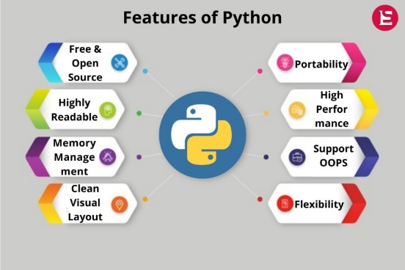

**Figure: - 1.0**

* **OPENCV (Python Library)**

OpenCV (Open-Source Computer Vision Library) is a library which mainly focuses at real-time computer vision. It is free for both academic and commercial use. It has C++, C, Python and Java interfaces and supports Windows, Linux, Mac OS, iOS and Android. OpenCV was designed for computational efficiency and with a strong focus on real-time applications. The library has more than 2500 optimized algorithms, which includes a comprehensive set of both classic and state-of-the-art computer vision and machine learning algorithms. It provides basic data structures for image processing with efficient optimizations.

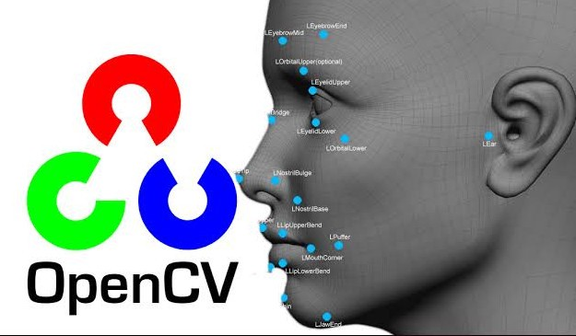

**Figure: - 2.0**

Sketching On Air is possible through our trending technology namely open cv, python. Open cv is mainly known as an open-source computer vision and machine learning software. The library has more than 2400 best algorithms, which includes comprehensive set of classic and state-of-the-art computer vision and machine learning algorithms. Most of these algorithms are used to detect and recognize faces, identify objects, classify human activities in videos track camera movements, track moving objects, extract 3D one’s.

The interaction between people and the machines is mainly completed through the mouse, keyboard, remote control, touch screen, and other direct contact manner, while the communication between people is basically achieved through more natural and intuitive non-contact manner, such as sound and physical movements.

**CHAPTER 2**

**LITERATURE REVIEW**

In the past decades, gestures were usually identified and judged by wearing data gloves to obtain the angles and positions of each joint in the gesture several papers and projects have targeted the issue of hand gesture recognition.

**Francis et al** However, it is difficult to use widely due to the cost and inconvenience of wearing the sensor. In contrast, the non-contact visual inspection methods have the advantage of low cost and comfort for the human body, which are the currently popular gesture recognition methods.

**Chakraborty** proposed the skin color models utilizing image pixel distribution in a given color space, which can significantly improve the detection accuracy in the presence of varying illumination conditions. However, it was difficult to achieve the desired results using the model-based methods because of the light sensitivity during the imaging process. The algorithm-based non-contact visual inspection methods were also used to conduct the gesture recognition, such as the hidden Markov model the particle filter, and Heer features AdaBoost learning algorithm; however, it is difficult to execute real time due to the complicated algorithms. The above results cannot acquire gestures efficiently in real time since only the insufficient 2D image information was used. Therefore, it is inevitable that gesture recognition by 2D image is replaced by 3D with depth information. In general, 3D information can be acquired by binocular cameras, Kinect sensor, Leap Motion and other devices. Those devices can be usually utilized to obtain depth information by spatial relationship of different direction or infrared reflection, which can conveniently acquire non-contact image for recognition and classification instead of wearing the complicated equipment.

To facilitate this process many gestures recognition applications resort to the use of uniquely colored gloves or markers on hands or fingers. But computer vision is a rapidly growing field, partly as a result of both cheaper and more capable cameras, partly because of affordable processing power, and partly because vision algorithms are starting to mature. By using Hand gestures user can communicate more information in less time period. So, for improving the interface.

The communication by natural and intuitive non-contact manner is usually considered to be flexible and efficient; many researchers have thus tried efforts to make the machine identify other intentions and information through the non-contact manner like people, such as sound, facial expressions, physical movements, and gestures. Among them, gesture is the most important part of human language, and its Gestures play very important roles in human communication also.

They are considered as the most easy means of communication between humans and computers gesture recognition has wide applications including sign language recognition, robotics and so on .gesture recognition can be simply categorized into two methods based on devices which are used to capture gestures: wearable sensor-based methods and optical camera-based methods. The example of device used in the wearable sensor based method is the data glove which is capable of exactly capturing the motion parameters of the user’s hands and it can achieve high recognition performance.

**LIMITATIONS**

* A person cannot identify a greater number of hands after a point.
* You need a wide scale of screen to use it efficiently.
* You cannot create 3-D structures.
* You need high brightness to detect hand and use if efficiently.
* You cannot identify hand of person unless you use mediapipe and mphands solutions.
* You need high system requirements and specific python libraries to use opencv hand and motion detection.

**CHAPTER 3**

**DESIGN AND DIAGRAMS**

The proposed system can be classified into mainly two steps after acquiring the input image from camera, videos or even an Object of Interest. These steps are: Extraction Method image pre-processing and Features estimation and Extraction.

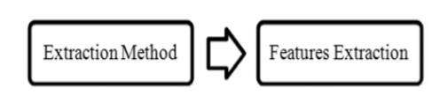

**Figure: - 3.0**

Segmentation process is the first process for recognizing Object of Interest. It is the process of dividing the input image (in this case Object of Interest image) into regions separated by boundaries.

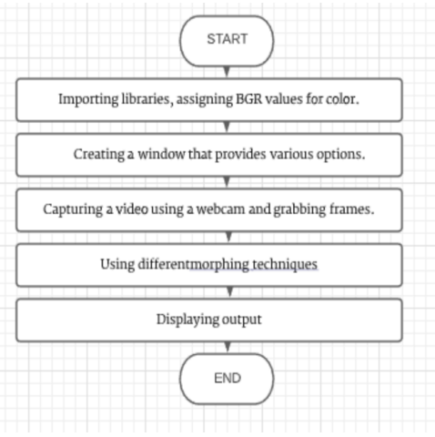

**Figure: - 3.1**

Good segmentation process leads to perfect features extraction process and the latter play an important role in a successful recognition process.

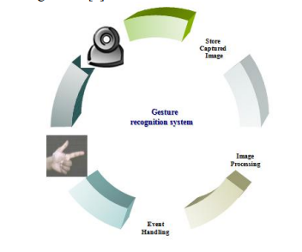

**Figure: - 4.0**

**CHAPTER 4**

**IMPLEMENATION DETAILS**

* **Importing Libraries**

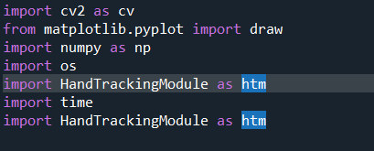

**Figure: - 5.0**

* 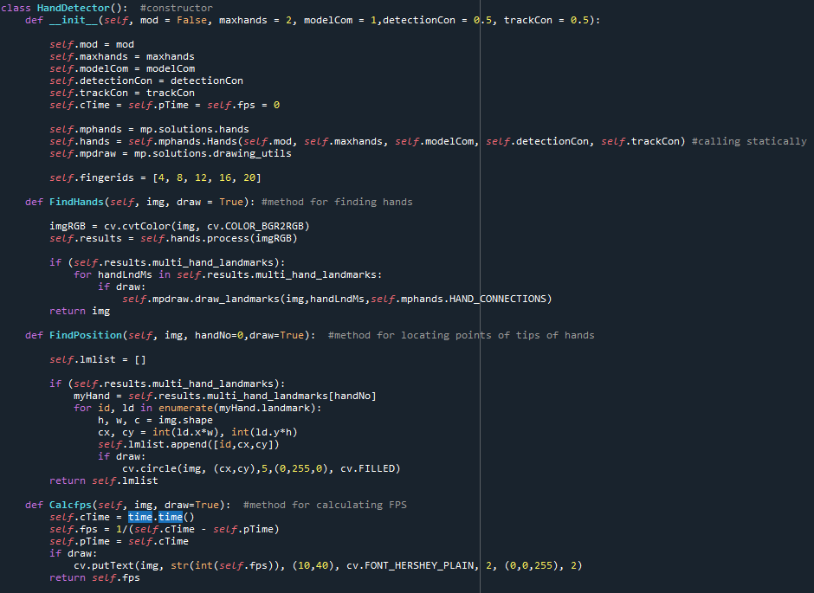**Hand Tracking Module**

**Figure: - 5.1**

**OUTPUT**

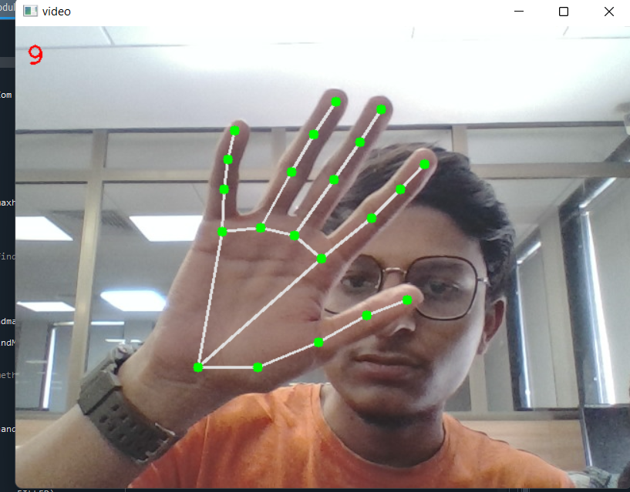

**Figure: - 6.0**

Now we use the OpenCV function cv2. VideoCapture() method to read a video, frame by frame (using a while loop), either from a video file or from a webcam in real-time. In this case, we pass 0 to the method to read from a webcam. We can just add the exact same paint interface for ease of usage. And using hand tracing module we track hands on the video screen.

With the following module we can use the module in any code we want we just need to import he module and use it accordingly. It also show FPS of the following tracked video.

* **Counting Fingers**

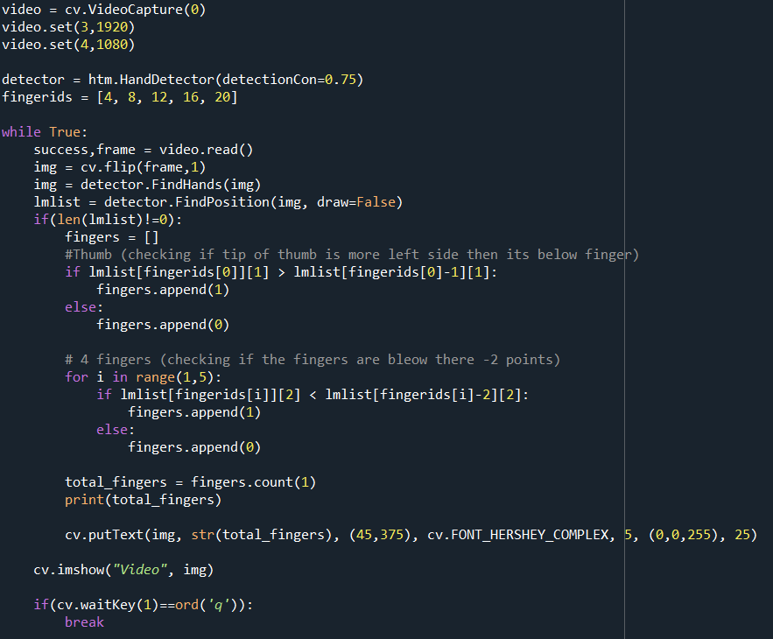

**Figure: - 7.0**

**OUTPUT**

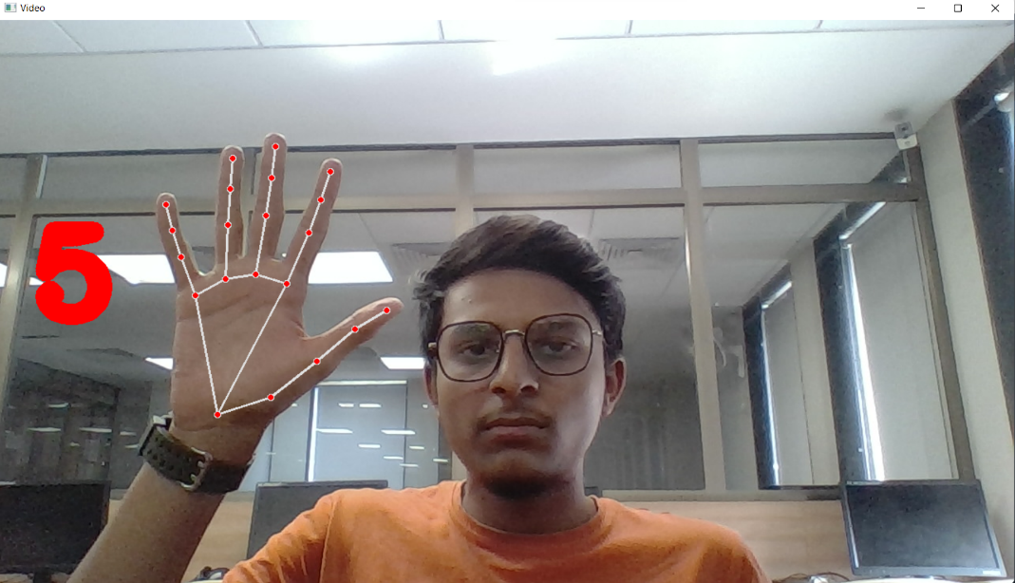

**Figure: - 8.0**

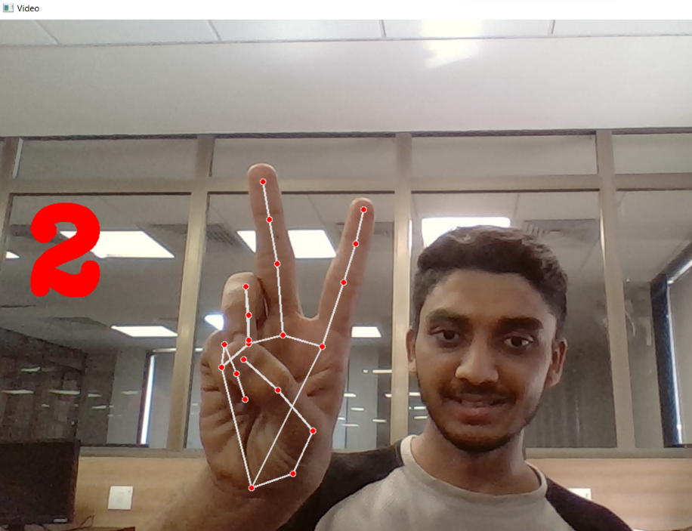

**Figure: - 8.1**

Now we created a code for counting fingers and getting which finger is open or up and how many fingers are down to switch between drawing mode and selecting mode.

We import this file to our main project file to use it as for changing modes.

* **Virtual Painting**
* **Importing all the images**

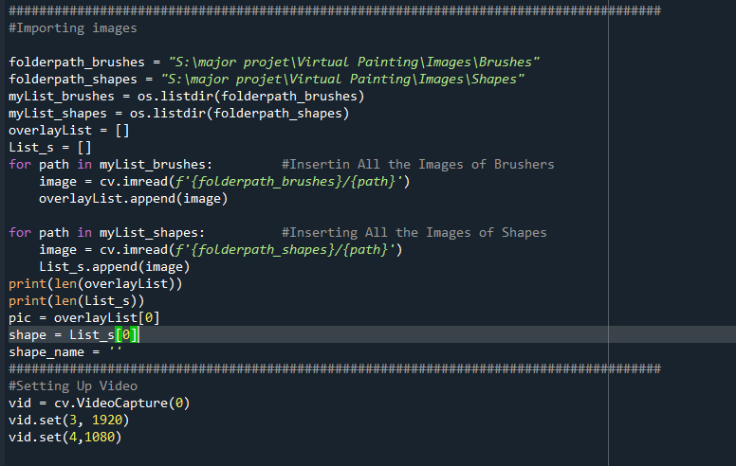

**Figure: - 9.0**

* **Drawing Hand Land Marks**

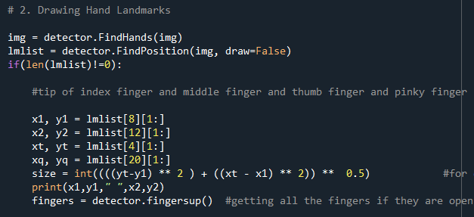

**Figure: - 9.1.0**

* **Checking for index finger and middle finger for changing selection mode and drawing mode**

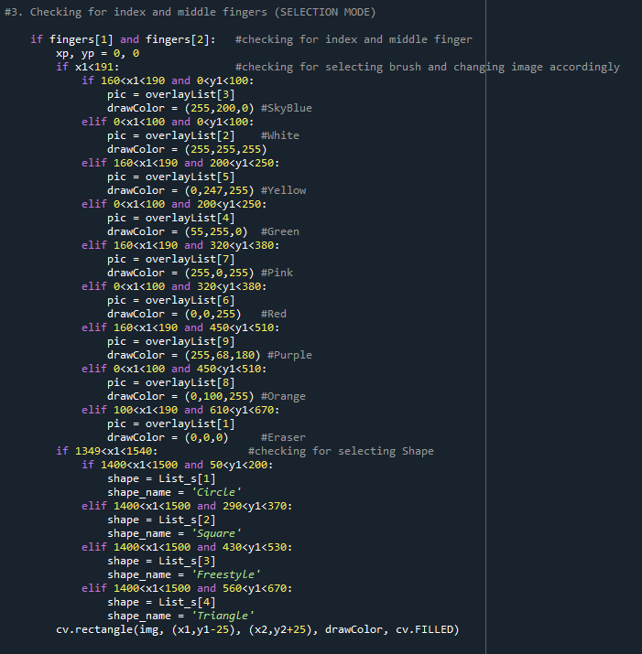

**Figure: - 10.0.0**

* **Checking for Shapes to draw**

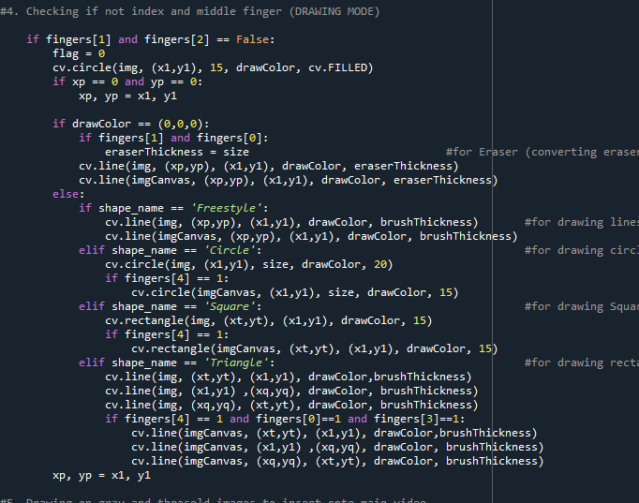

**Figure: - 11.0.0**

Importing all the created files and modules to one file and using all to make an Virtual painting project.Now we start tracking coordinates of each point the centre of the contour touches on the screen, along with its colour. We store these set of points of different colours in different deques (bpoints, gpoints etc.). When the centre of the contour touches one of the coloured boxes we put on the screen in Step 1, we store the points in its respective colour deque.

**OUTPUT**

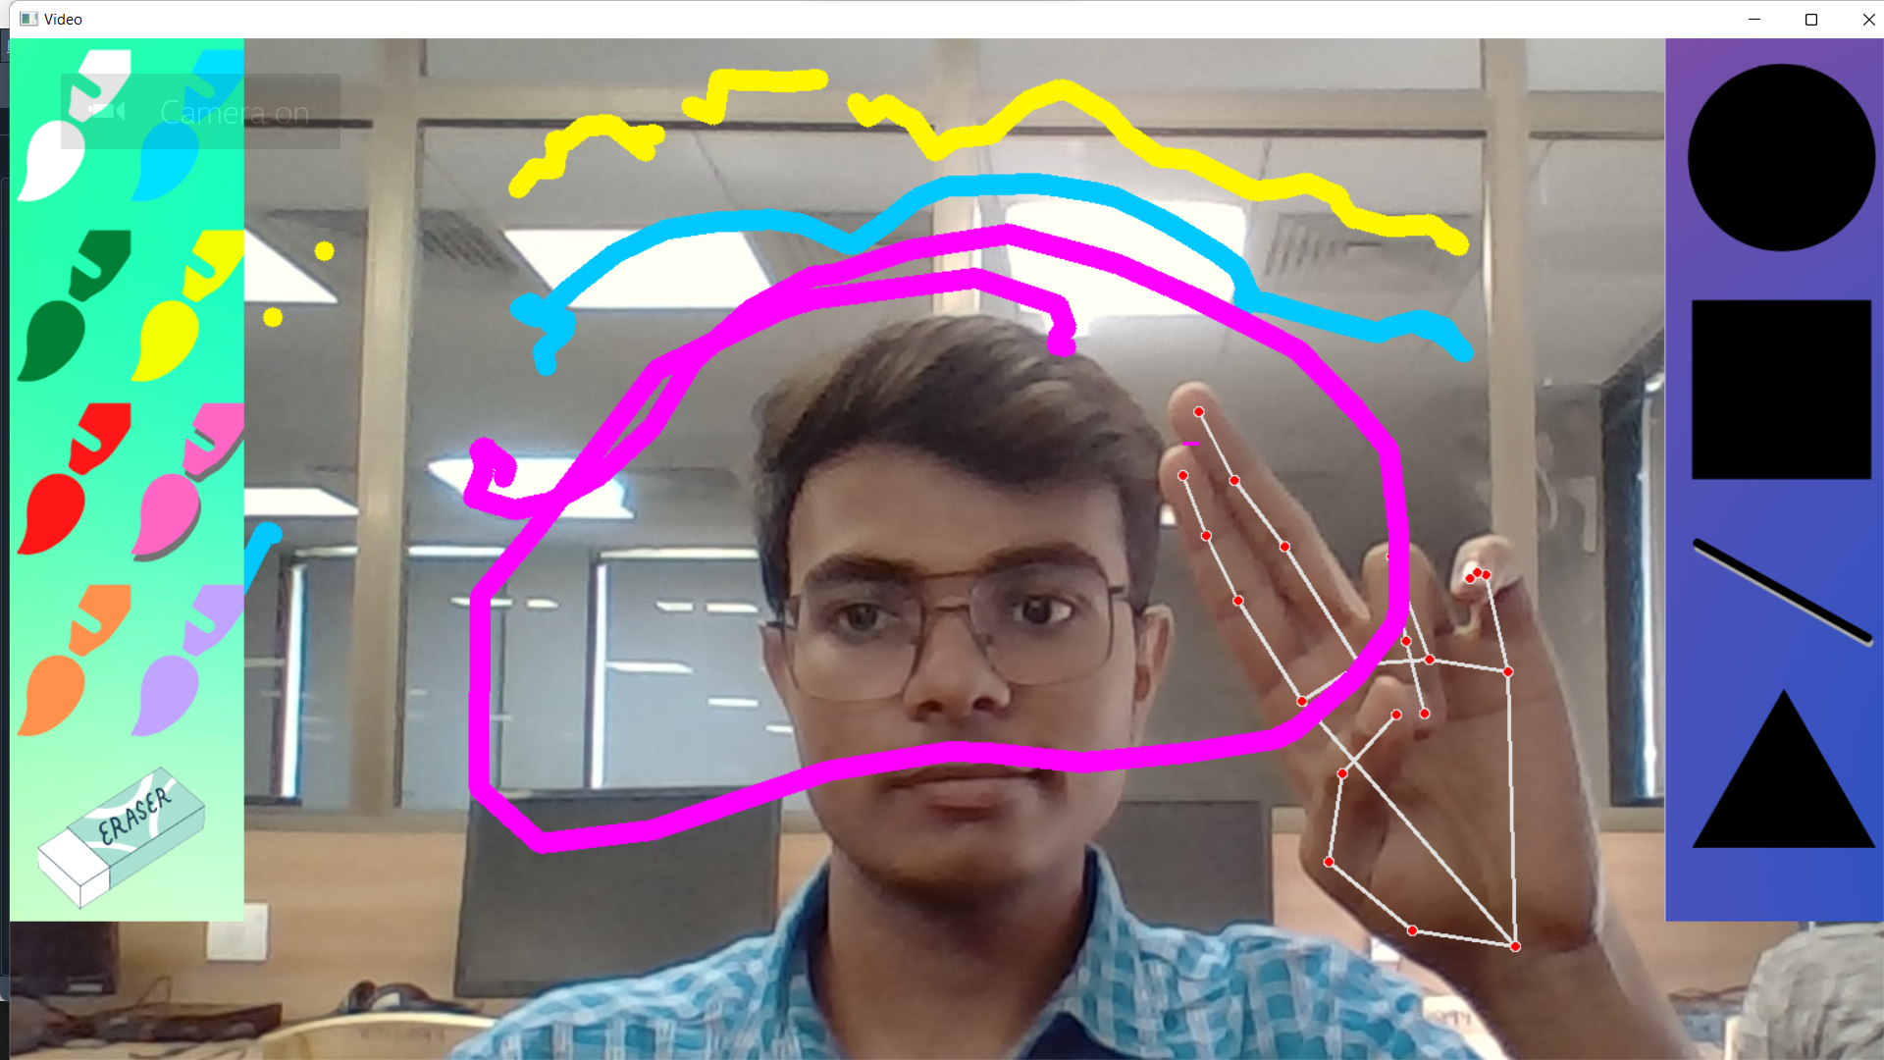

**Figure: - 12.0.0**

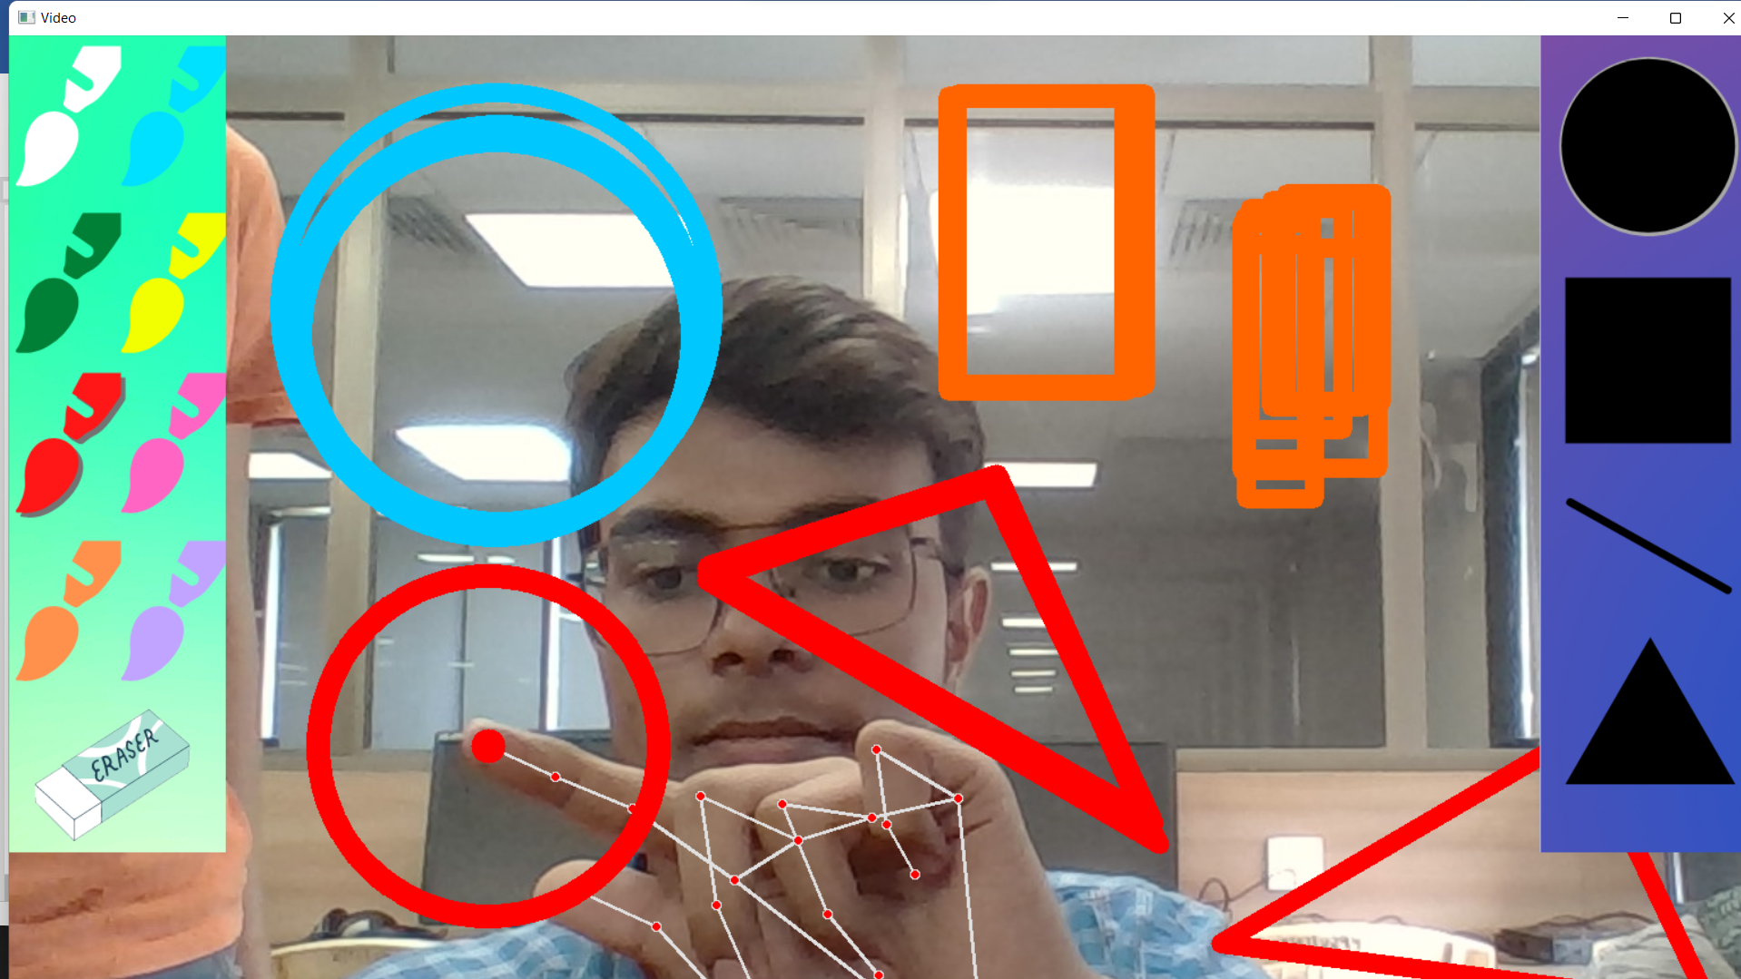

**Figure: - 12.1.0**

**CHAPTER 5**

**CONCLUSION AND FUTURE WORK**

**CONCLUSION**

This project makes the user to have an interactive environment where the user can draw whatever he wants by choosing his required colors from the displayed ones.

So, we conclude that Virtual Sketch is developed using the library NumPy and in Open CV where we have many libraries and algorithm in built which makes the interfaces more active while using . We used python as, it have many inbuilt libraries and many modules which represent the imagination virtually when used along with OpenCV as well as its morphological processes

Demonstration of the image processing capabilities of OpenCV. The ultimate goal is to create a computer vision machine learning application that promotes Human computer interaction (HCI) also named ManMachine Interaction (MMI)] refers to the relation between the human and the computer or more precisely the machine

**FUTURE WORK**

* Without any dark background hand gesture will be detected from the image.
* More sophisticated ways of Gesture recognition from various other human actions will take place instead of just hand gestures.
* Voice recognition system will be coupled with gesture recognition system which will then completely remove the requirement of hardware like Key-board and Mouse
* Video processing using Mobile devices such as smart phones, iPads and tablet pcs are equipped with cameras, the demand of the image processing applications increased.
* Controlling the robot using gestures considered as one of the interesting applications in this field proposed a system that uses the numbering to count the five fingers for controlling a robot using hand pose signs.

REFERENCES

* https://towardsdatascience.com/Painting-withopencv
* <https://www.geeksforgeeks.org/live-webcamdrawing-using-opencv>
* OpenCV for Computer Vision Applications
* <https://docs.opencv.org/master/d5/d54/group__obj>
* <https://circuitdigest.com/tutorial/real-life-objectdetection-using-opencv-python-detectingobjects-in-live-video>
* http://en.m.wikipedia.org/wiki/Object_detection